TO: Elizabeth Fontain, Town Clerk, Lovettsville, Va
RE: Formal Ethics Complaint — Christopher Hornbaker, Candidate for Mayor of Lovettsville
DATE: September 27, 2026
Madam Clerk,
I am submitting this formal ethics complaint concerning the use of an official Town of Lovettsville social-media asset to publish and promote express campaign advocacy for Mayor Christopher Hornbaker.
I respectfully request that the Town investigate this matter under the Town of Lovettsville Social Media Policy, the Standards of Conduct and Ethics for Town Government, applicable Town policies governing the use of Town resources, and any applicable provisions of Virginia law.

1. The social-media account involved is an official Town asset
The Town of Lovettsville's Social Media Policy, adopted June 12, 2025, expressly identifies “Lovettsville Oktoberfest” among the Town's recognized official social-media assets.
The policy limits Town social-media assets to factual Town business and emergency communications and restricts their content.
The policy also states that communications through official Town social-media assets are subject to public-record and transparency obligations.
The attached screenshot identifies the page as Lovettsville Oktoberfest and displays the Town-related disclosure concerning its social-media content.

2. The post contains express political advocacy
The attached evidence shows a “Sponsorship Spotlight” post published by the Lovettsville Oktoberfest page concerning Mayor Christopher Hornbaker.
The post states that Hornbaker was a Bronze Sponsor of the 30th Lovettsville Oktoberfest and identifies his donation as helping sponsor Town gift cards for Oktoberfest activities.
More importantly, the post reproduces the following campaign message from Mayor Hornbaker:
“I ask for your continued trust and vote Christopher Hornbaker for Lovettsville Mayor on November 3rd!”
The message also provides his campaign telephone number and campaign email address.
The accompanying campaign graphic is expressly identified as:
“Property of & Paid for by Hornbaker for Lovettsville.”
These facts establish that the material was not merely a reference to the Mayor's official position or a factual announcement concerning a Town event. It contains an explicit solicitation for votes for a clearly identified candidate for Mayor.

3. The Town's Social Media Policy expressly prohibits this conduct
Section 4(d) of the Town's Social Media Policy provides that posts associated with Town social-media assets shall not, “under any circumstances,” engage in political advocacy.
The challenged post contains an explicit request that voters support and vote for Christopher Hornbaker for Mayor.
Accordingly, I ask the Town to determine:
- Who authorized the publication of the post;
- Who created or submitted the political content;
- Who approved its publication;
- Whether the post was published by a Town employee, Town official, event committee member, contractor, volunteer, or another person with administrative access to the official Town account;
- Whether Town personnel, Town-paid services, Town equipment, Town advertising resources, or other Town resources were used in creating, approving, distributing, or promoting the campaign material; and
- Whether the post remains accessible on any Town-controlled social-media account or archive and whether it was cross-posted or shared to any other social media apps or other Facebook accounts.

4. The conduct should also be reviewed under the Town's Standards of Conduct and Ethics
The Town's Standards of Conduct and Ethics expressly apply to the Mayor and members of Town Government. They require Town officials to exercise their responsibilities consistent with their fiduciary obligations to the Town and require Town resources and decisions to be used for Town business purposes.
The Standards further prohibit a Town official from improperly leveraging or utilizing Town resources for personal gain and require officials to avoid relationships creating the appearance of improper influence or improper stewardship of Town resources.

I am not asking the Town to assume that every campaign-related benefit constitutes “personal gain” under the Standards. Rather, I request that the Town determine whether the use of an official Town communication platform to distribute an incumbent candidate's explicit request for votes constituted improper use or stewardship of a Town resource.

5. Review under applicable Virginia election law
The evidence should also be referred to the appropriate election authorities for review of any potentially applicable Virginia campaign-finance or political-advertising requirements. State elections officials have been notified of this complaint.
Virginia law defines a campaign contribution broadly to include money, services, in-kind contributions, and other things of value provided for the purpose of expressly advocating the election of a clearly identified candidate. It likewise defines an in-kind contribution to include goods, services, property, or another thing of value provided without charge or below the usual and normal charge.
I recognize that Virginia's Campaign Finance Disclosure Act contains a specific exception for elections for town offices in towns with populations below 25,000, subject to the statutory exceptions concerning campaign activity exceeding $25,000 or adoption of the statute by local ordinance. I therefore request an investigation and determination by the appropriate election authority rather than making an unsupported conclusion that the Campaign Finance Disclosure Act was violated.
The Town should also determine whether the use of an official Town social-media resource raises any issue under Virginia law governing unauthorized use of public assets. Virginia Code § 18.2-112.1 specifically addresses unauthorized use of public assets belonging to or paid for by a town and establishes statutory thresholds and conditions for enforcement.

6. Loudoun County ethics standards
I recognize that the Loudoun County Board of Supervisors' Code of Ethics and Standards of Conduct governs County supervisors and does not itself govern the Town Mayor.
Nevertheless, the County's adopted standards provide a useful governmental ethics benchmark within Loudoun County. They require elected officials to comply with laws governing political campaigns, avoid even the appearance of conflicts, grant no special favors or privileges, and use County resources and staff only to conduct County business.
I therefore request that the Town apply its own substantially similar principles of responsible stewardship and separation of governmental resources from campaign activity when reviewing this matter. County election officials have been notified of this complaint.

7. Requested action
I respectfully request that the Town:
- Open a formal ethics review of the publication, and that investigation be transparent and public;
- Preserve the original post, associated images, administrative records, metadata, messages, emails, and other records relating to its creation, submission, approval and publication;
- Identify the individual or individuals who authorized and published the post, and determine if they were coerced by the candidate;
- Determine whether Town employees, officials, contractors, volunteers, equipment, accounts, advertising resources, or other Town resources were used in connection with the campaign message;
- Determine whether the publication violated Section 4(d) of the Town Social Media Policy prohibiting political advocacy;
- Determine whether any provision of the Town's Standards of Conduct and Ethics or other Town policy was implicated;
- Determine whether the matter should be referred to the Virginia Department of Elections, Commonwealth's Attorney, Town Attorney, or another appropriate governmental authority for review of any potential state-law issue;
- Remove or correct the campaign material from any official Town-controlled social-media asset, consistent with applicable public-records and records-retention requirements;
- Take whatever corrective or disciplinary action is authorized under the Town's Social Media Policy and applicable Town policies; and
- Provide me with the Town's written determination and the basis for that determination.
An official Town of Lovettsville social-media asset appears to have published express advocacy asking residents to vote for the incumbent Mayor in his campaign for reelection, notwithstanding a Town policy expressly providing that Town social-media assets shall not engage in political advocacy.
That distinction is important because elected officials retain their constitutional rights to campaign and express political views in their private capacities. The concern here is the apparent use of an official governmental communication resource for that campaign activity. I submit these Facebook screen shots with relevant content highlighted by red squares.

EXHIBITS:
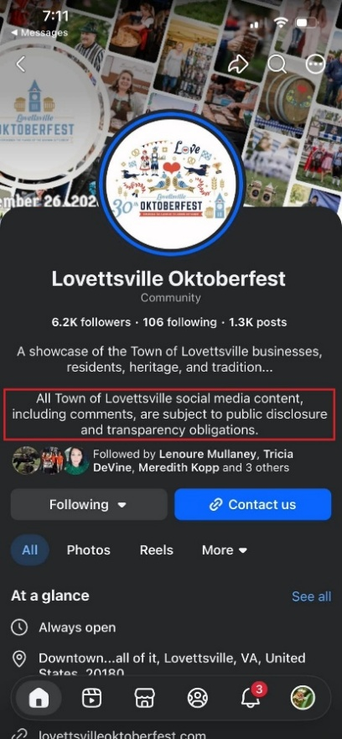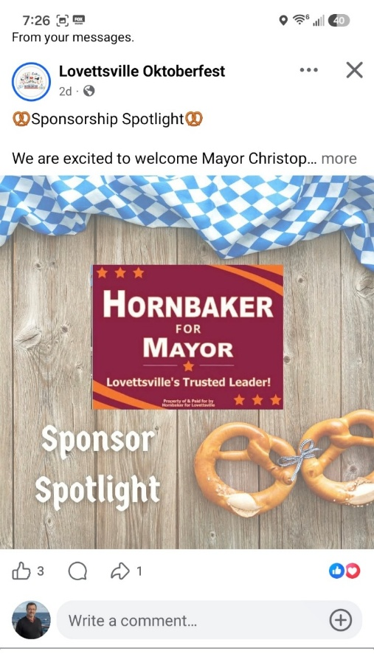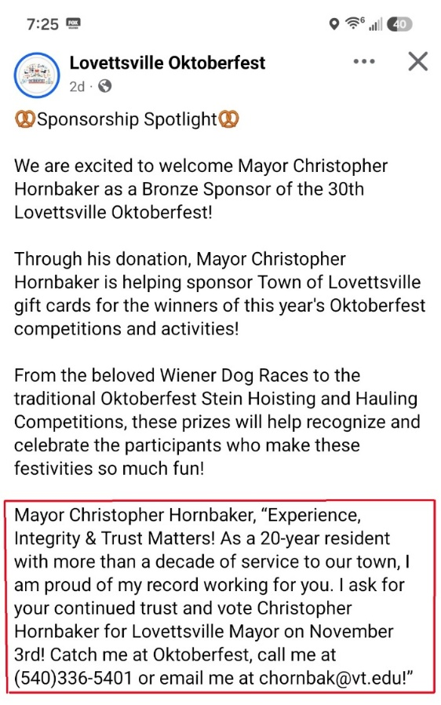
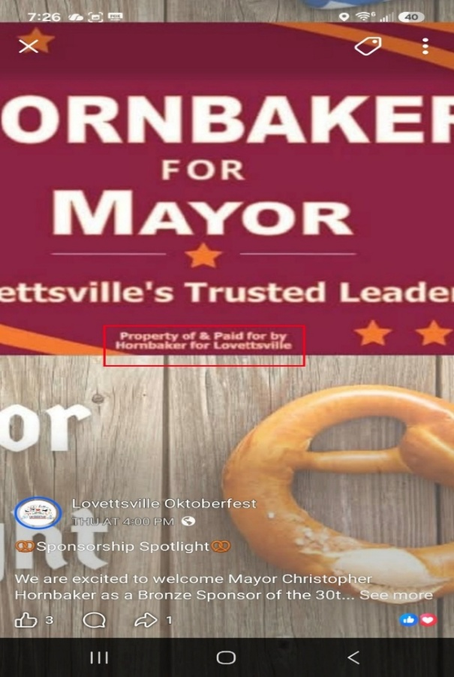

I respectfully request that this matter be investigated on that basis and that the Town preserve all records relating to the publication pending completion of the review. I further request that due to the short amount of time remaining before the election, these actions be expedited to give town residents a full view of the transparency they have been promised by town leaders over the years.
Respectfully,
Frank E. McDonough
25 S. Loudoun Street, Lovettsville Va, 20180
fmcdonough@outlook.com
703-678-1682
9/28/2026

